From: <https://stateofthenation.co/?p=181458>

Posted on August 18, 2023 by State of the Nation

The White-Hot Fuel of the Maui Firestorm

Video Player [available @ line 1 above.]

00:00

00:48

By James Grundvig, American Media Periscope

The 40-mile-per-hour wind and higher gusts neither sparked the Maui fires nor provided the fuel to incinerate 2,200 structures. The winds didn’t spread the fire to magically leap over the water burning the boats that had pulled offshore. Yes, the winds acted as a giant bellow. But they didn’t ignite or spark the blaze.

Fuel was needed. A lot of it.

Fuel, the most critical element of the Maui firestorm, didn’t come from the sparse trees that are still standing. If not a wildfire, then what was the fuel that flash-lit the fires to burn across different mediums and materials? What ignited the fires that burned metals and plastics, superheated CMU block and brick, melted windshields and wheel-rim metal alloys and the fiberglass boats pulled out of the harbor?

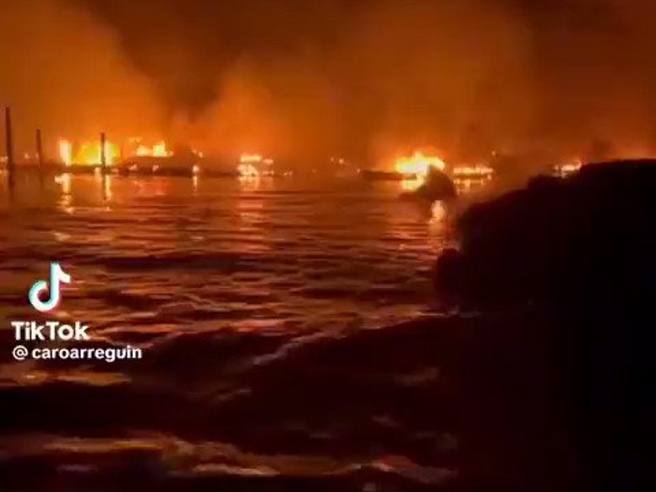

[Credit: TikTok @caroarreguin.]

The answer resides in the distant and near past of Maui.

**The Maui Chemtrails Fight**

For more than a decade, the hardy people of Maui fought to bring clear blue skies back to the tropical paradise by banning the [geoengineering](https://www.naturalnews.com/033691_chemtrails_Maui.html) of their skies.

In 2011, a host of initiatives, from “[Maui Clean Sky Ordinance](https://de-de.facebook.com/MauiCleanSkyOrdinance)” to “[Maui Sky Watch,](https://mauiskywatch.org/)” tried in vain to stop the [spraying](https://thefreedomarticles.com/amp/geoengineering-over-maui-fake-clouds-spotted/) of the metals nanodust over the Hawaiian archipelago. But the military-contracted planes continued to rain the metal shavings down on the island that hosts a pair of extinct volcanoes.

The three main elements used in chemtrail cocktails include **barium (BA), aluminum (AL), and**[**Strontium-90**](https://en.wikipedia.org/wiki/Strontium-90)**(90Sr), a radioactive isotope**. For those awakening now to the spraying overhead, note that barium and aluminum combined make “Ba’al,” one of the demonic gods that humans with lower frequency worship.

In 2015, Maui resident [Michael Murphy](https://www.youtube.com/watch?v=ZQQwN9wqqNA) got together with the mayor to stop the aerosol spraying with the bill “[Blue Sky Ordinance](https://www.thetruthdenied.com/news/2011/10/18/michael-murphy-makes-headway-with-blue-sky-ordinance-in-hawaii/)” that sought to ban geoengineering the skies.

All such efforts, whether in Hawaii or mainland United States never succeeded in stopping the weather modification,

the [Strategic Aerosol Injection](https://www.frontiersin.org/articles/10.3389/fclim.2021.720312/full) (SAI), and

the [Solar Radiation Management](https://www.wilsoncenter.org/article/solar-radiation-management) (SRM) programs that account for many of the chemtrail planes in the sky, but not all of them.

On the surface, the government and its captured agencies run the cover story of climate change, but the spraying of Ba’al+ chemtrails around the world serves a different purpose. Chemtrails dry out trees, bushes, and vegetation while making the land arid, and poisoning the air and water.

As we all know, there is a long history of forest fires in the United States. Particularly in drought-stricken areas or California with its infamous Santa Ana winds. But there is not only an uptick in such fires this summer—Canada, Louisiana, Texas, Pacific Northwest—but also a surge in the ferocity of the firestorms that nuked Santa Rosa in October 2017 in **the “**[**Wine C**](https://www.nbcnews.com/news/us-news/california-wildfire-killed-22-wine-country-was-caused-homeowner-equipment-n962521)**ountry Fire**,” and **the Campfire inferno that burned**[**Paradise**](https://www.thetruthdenied.com/news/2011/10/18/michael-murphy-makes-headway-with-blue-sky-ordinance-in-hawaii/)**, California, off the map** the following year.

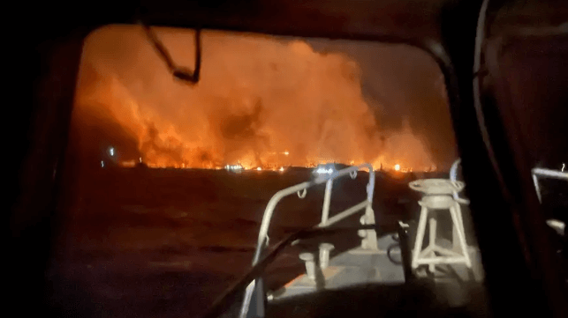

[Credit: A U.S. Coast Guard rescue boat stands by to assist as fires burn on the shores of Lahaina, August 9 (USCG) – public domain.]

**The Chemtrail layer represents a flashpoint for the spark, with Directed Energy Weapons (DEW) such as the HAARP array or military-grade lasers.** Still, this one-two punch doesn’t explain the intensity and swift spread of the fires, nor does the high winds.

Something else was at play.

**The Fuel of Ammonium Nitrate**

In May [30 tons](https://www.businessinsider.com/30-tons-of-explosive-chemicals-disappeared-from-railcar-officials-2023-5?op=1) of ammonium nitrate—fertilizer—disappeared off a train in California. Since ammonium nitrate has been used previously in car bombs from the 1995 Oklahoma City bombing to the Oslo, Norway, blast in 2011, many researchers wrongly suggested that the fertilizer component turned the Canadian fires [toxic cloud](https://winepressnews.com/2023/06/09/as-millions-of-americans-are-forced-to-inhale-toxic-smog-trump-gets-indicted-in-another-diversionary-distraction-was-ammonium-nitrate-the-cause/), which hung over New York City, a deep orange-reddish hue. But that wasn’t the case since ammonium nitrate rarely burns red.

[Ammonium nitrate](https://www.nfpa.org/~/media/Files/Code%20or%20topic%20fact%20sheets/AmmoniumNitrateFactSheet.pdf) (NH4NO3) burns or decomposes. By itself, it’s not flammable and cannot combust. Most often, when it does burn, ammonium nitrate produces a white or light-colored smoke. Not blood red. Why would the Deep State transport the 60,000 pounds of stolen material across the country to New York State?

It makes no sense. But shipping or flying the stolen ammonium nitrate to Hawaii from California follows the principle of Occam’s razor. Proximity with the fewest moves needed to complete the mission.

Ammonium nitrate is an oxidizer; it supports the combustion of other materials. When a violent reaction occurs, such as a bomb blast or explosion, the ensuing cloud is made up mostly of [nitrogen oxide](https://scied.ucar.edu/learning-zone/air-quality/nitrogen-oxides) and water vapor. In essence, ammonium nitrate releases oxygen. Oxygen is the fuel a fire needs to burst and spread.

Now **add the coatings of the nanodust metals from years of chemtrail with a new layer of ammonium nitrate and all the Maui firestorm needed was the spark.** Yes, the DEW device, whether a laser from a passing plane, satellite-based, or Chinese spy balloon. **It wouldn’t take much to blow the inferno wide open at night.**

The Deep State created the perfect fuel, which explained how the boats, vehicles, and structures all burned at once, and why the trees survived for the most part, including the 150-year-old banyan tree that centers Lahaina.

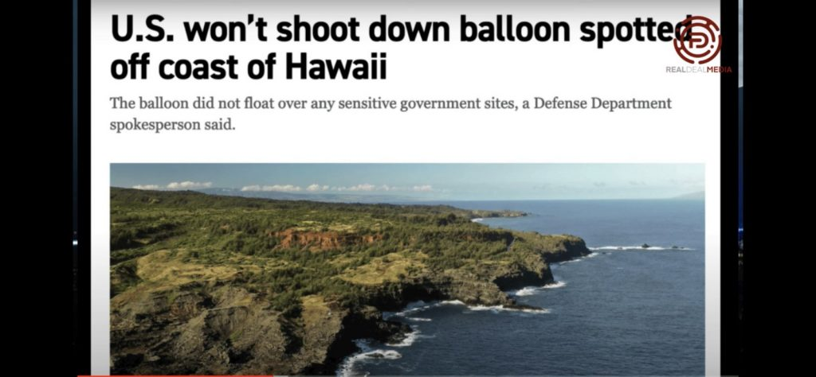

Some many anomalies and questions remain unanswered yet.

We do know that President Joe Biden weighed in on Maui, using the double entendre in his post yesterday: “We’re laser-focused…” No doubt. Like a DEW laser beam.

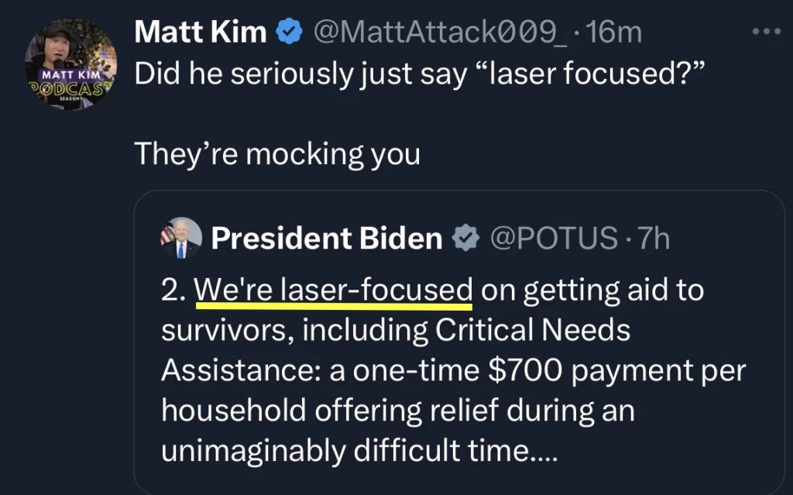

We also know that Hawaiian Governor Josh Green wants to “acquire the land” of ruined Lahaina to “protect Hawaiians from overseas corporations,” when Hawaii itself is incorporated, with apparently its leadership behold to the World Economic Forum’s global agenda to [get] people off their land (fires, famine, drought), **and** migrate them into cubical apartments of Smart Cities run by AI.

We can also rule out “climate change” with both [*CBS News*](https://www.cbsnews.com/news/maui-wildfires-climate-change-drought-conditions/) and [*ABC N*](https://www.msn.com/en-us/weather/topstories/why-climate-change-cant-be-blamed-entirely-for-the-maui-wildfires/ar-AA1fgQwF)ews tiptoeing around the farcical idea that an increase in earth’s greenhouse gases caused the massive inferno, that targeted only one of Hawaii’s 137 islands and atolls. No, the evidence can be seen in the drone footage video up top showing a white coating of dust on the collapsed rooftops and structures, most of the vehicles, and on the streets and ground, suggesting that ammonium nitrate was used as **an accelerant** and **an oxidizing agent**.

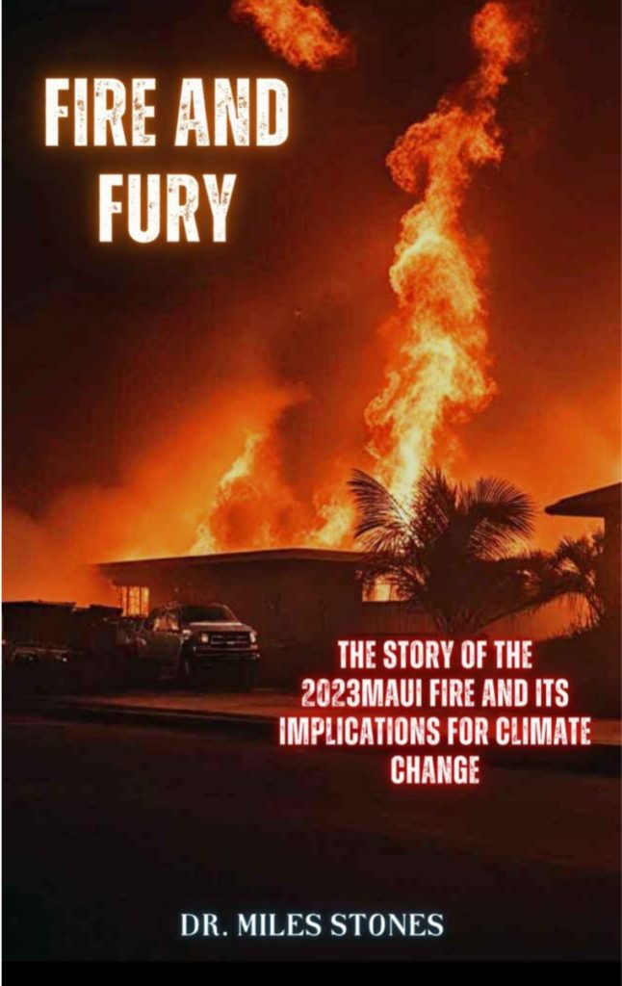

As for the fact-checkers and mainstream media, they ignore all of the predictive programming material and psyop of turning modern Maui into a transhuman [smart island](https://truthcomestolight.com/on-the-wef-global-plans-for-smart-city-governance-who-caused-the-fire-in-hawaii/). Calling it a “coincidence” is a joke, a disingenuous lie, and misinformation of the highest order.

Remember, the Biden regime and bureaucrats in the Pentagon blocked the U.S. Army from responding to the search for bodies and aid to the survivors on Maui.

[Below: Lahaina is 1 of over 10 15-Minute Cities in The JUMPSmartMaui Project. -FNC]

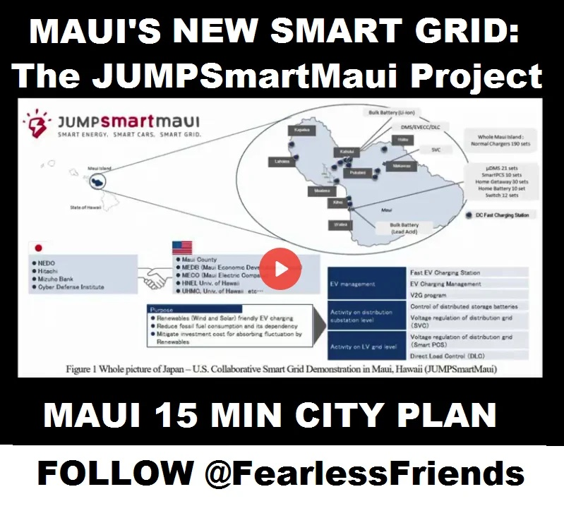

Finally, the lowball number of dead–96 as of yesterday–is a coverup and lie. An entire school of children is missing, along with many people who drowned in the hot smoky water when they abandoned their burning cars.

___  
<https://americanmediaperiscope.com/the-white-hot-fuel-of-the-maui-firestorm/>

This entry was posted in [Uncategorized](https://stateofthenation.co/?cat=1). Bookmark the [permalink](https://stateofthenation.co/?p=181458).